
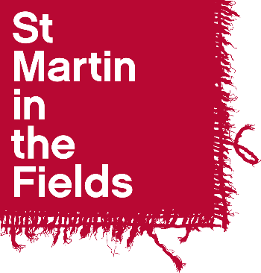

Diocese of Manchester

Bass Choral Scholar 2025-26:

Application Form

Name: ……………………………………………………………………

1. Personal Details

Full Name: | Contact Telephone Number(s):
Preferred pronouns e.g. he/him: | Email:
Contact Address:

2. References

If you are shortlisted for an audition we may wish to take up references. You should give the name of one musical referee who has experience of your singing and one other referee who can give us a character reference.

First Referee
Name:
Position:
Relationship to you:
Address:
Telephone Number:
Email address:
May we contact this referee prior to interview? Yes □ No □

Second Referee
Name:
Position:
Relationship to you:
Address:

Telephone Number:
Email address:
May we contact this referee prior to interview? Yes □ No □
3. Education

Schools, Colleges, Universities or Institutes of Further Education attended (including part time) | Dates |  | Qualifications gained
 | From | To

- Please answer the following questions

Your answers will provide the basis for some discussion in the interview.
1. Why are you applying for a Choral Scholarship with the Diocese of Manchester?
2. What do you plan to be doing alongside the scholarship (e.g. university / college course; gap year etc) and how do you see this arrangement working in terms of compatibility and time management?
3. How would the scholarship fit in with your plans for the future?

- Declaration

I certify that the information I have provided on this application form is correct and agree that the information given can be used as a basis for some discussion in the scholarship interview.

Signed: ………………………………………………………………….. Date: ………………………………

Please return this form, along with a current CV, by email to Harrison Knights, Music
Administrator at harrison.knights@smitf.org

The deadline for applications is 12pm (midday) on Monday 16th June 2025.

Auditions for shortlisted applicants will take place in-person in Manchester on Wednesday 18th June 2025 between 4pm - 6pm.

