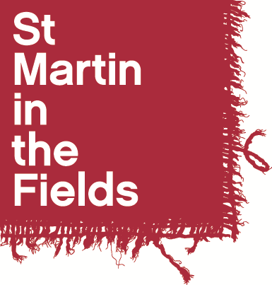
St Martin-in-the-Fields Emerging Artists Programme
September 2025 to June 2026

Application Form

Name: ……………………………………………………………………

Voice Part: Soprano / Alto / Tenor / Bass

- Personal Details

Full Name: | Contact Telephone Number(s):
Preferred pronouns e.g. she/her: | Email:
Contact Address:

Personal Statement

Please write a personal statement of no more than 600 words. This should detail your reasons for applying, relevant experience and what you hope to gain from the St Martin-in-the-Fields Emerging Artists Programme 2025-26.

References

If you are selected for an audition, we may wish to take up references. You should give the name of your current singing teacher, and a choral director.

First Referee (your current singing teacher)
Name:
Position:
Relationship to you:
Address:

Telephone number:
Email address:

Second Referee (a choral director)
Name:
Position:
Relationship to you:
Address:

Telephone number:
Email address:

Availability

We will notify you of performance dates as early as possible, and the current list of performances and projects planned for 2025-26 are on the information pack. Whilst this list is not exhaustive, by applying to this programme you are agreeing that you are available for all performance dates listed.

A reminder of the term dates

Autumn w/c 15th September – w/c 1st December (12 weeks)
Spring w/c 19th January – w/c 23rd March (10 weeks)
Summer w/c 20th April – w/c 22nd June (10 weeks)

Auditions
Auditions will take place during the following times:

- Monday 30th June, 2.00pm – 4.30pm
- Wednesday 2nd July, 6.30pm – 9.00pm
- Saturday 5th July, 11.30am – 3.00pm

Please indicate your availability on the table below. Shortlisted applicants will be asked to perform a solo piece of up to 4 minutes in length, undertake sight-reading, vocal and aural exercises and will be given a short interview.

Audition Date | Please indicate your availability here
Monday 30th June, 2.00pm – 4.30pm
Wednesday 2nd July, 6.30pm – 9.00pm
Saturday 5th July, 11.30am – 3.00pm

Declaration

I certify that the information I have provided on this application form is correct and agree that the information given can be used as a basis for discussion in the interview.

Signed: …………………………………………………………… Date: ………………………………

Please return this form, along with a current CV, by email to alicia.hinchliffe@smitf.org or by post to: Alicia Hinchliffe, Music Programme Manager, St Martin-in-the-Fields, Trafalgar Square, London WC2N 4JJ.

The closing date for applications is Sunday 22nd June.

