PRESS RELEASE for immediate release
HeartEdge launches on 8 February 2017
at St Stephen Walbrook, London
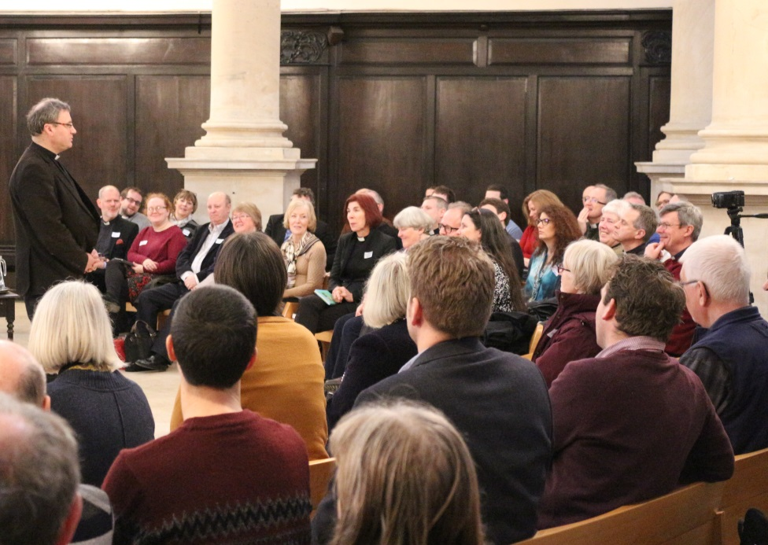
HeartEdge is a network of initiated by St Martin-in-the-Fields for churches working at the heart of culture, community and commerce with those at the margins and on the edge. HeartEdge aims to build association, learning, development and resource.
February 8 saw the launch of HeartEdge with a day exploring mission by sharing ideas, uncovering solutions and finding support held at St Stephen Walbrook, London and hosted by Revd Dr Sam Wells. 80+ attendees heard a wide range of contributions from Jonathan Evens (Priest for Partnership Development, St Martin-in-the-Fields and St Stephen Walbrook), Jessica Foster (Curate, St Peter's Hall Green Birmingham), Ruth Gouldbourne (Minister at Bloomsbury Central Baptist Church), James Hutchings (Team Rector, Holy Trinity Exmouth), Ali Lyon (Consultant and member of St Martin-in-the-Fields), Rosemarie Mallett (Rector of St John’s Angell Town, Brixton), Sally Muggeridge (Curate, St Stephen Walbrook), Andy Turner (Project Co-ordinator, HeartEdge), Dan Tyndall (Vicar of St Mary Redcliffe, Bristol), Tim Vreugdenhil (Pastor of CityKirk Amsterdam), and Lucy Winkett (Rector, St James’s Church, Piccadilly).
Following the event Sam Wells said, 'I was so delighted to see so many energised and engaged faces at the HeartEdge launch as we spoke about structures, configurations, approaches, insights – but most of all of renewal of vocation, vision and common exploration. That left me full of hope for the emergence of HeartEdge – a movement as yet of many different words but one purposeful spirit. I hope you will sign up and encourage others to do so.'
HeartEdge supports churches in blending their mission around four key areas:
- Congregation – Inclusive approaches to liturgy, worship and day-to-day communal life
- Community – models of outreach serving local need and addressing social justice
- Culture – art, music and ideas to re-imagine the Christian narrative for the present moment
- Commerce – Commercial activities that generate finance, creatively extending and enhancing mission and ministry through social enterprise

HeartEdge works with its members in finding their stories, sharing resources and connecting effectively with others developing their church and community. We create spaces where members give from their experience and take from others – an exchange that’s often inspiring, always compelling, and mutually useful for all participants. We want HeartEdge to be an essential resource and a valuable community, as members develop their church and neighbourhood.

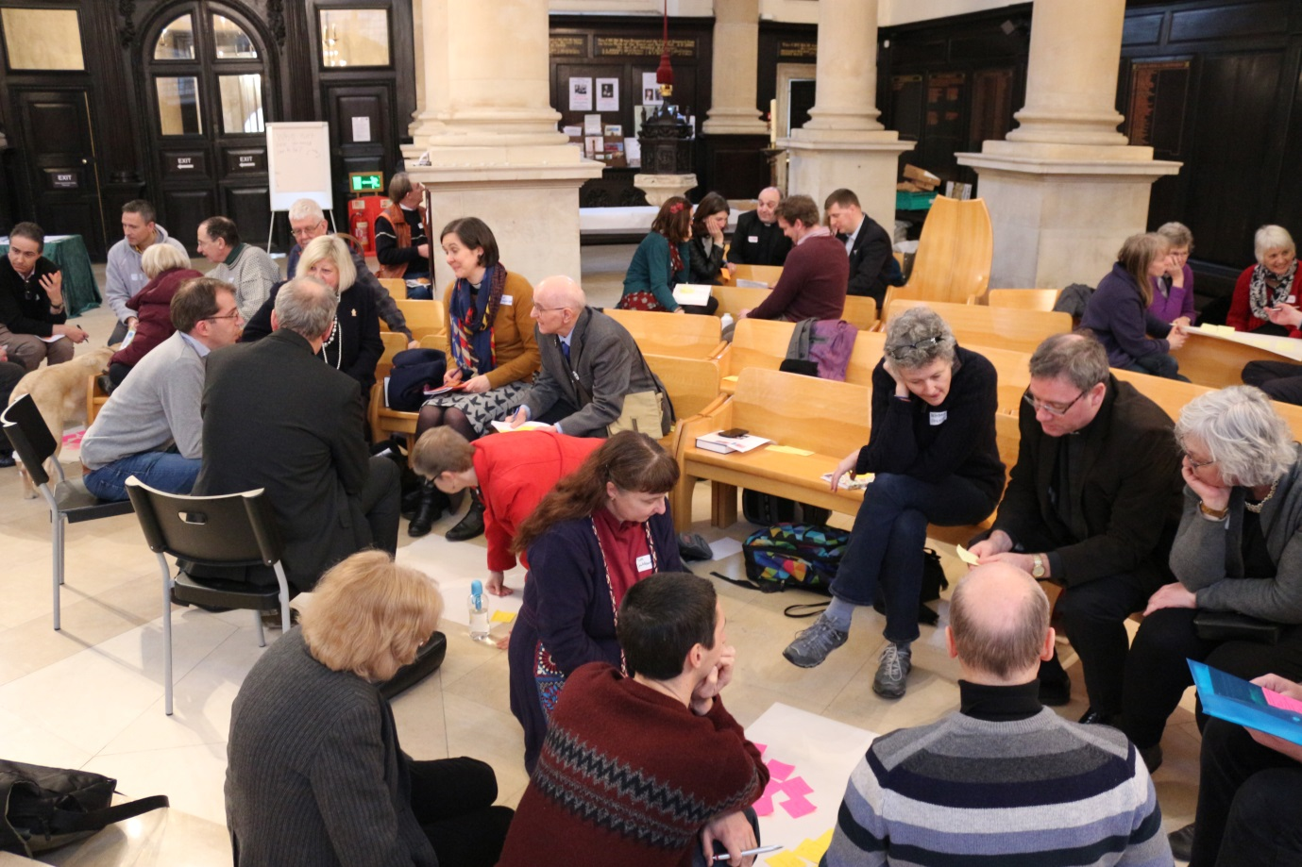

When churches join HeartEdge they receive :
- Connections: Access to all kinds of useful contacts and connections to help their church develop cultural, commercial and community activity
- Information: Grow knowledge and insight to help in their work via the lived experience of others
- Visits: Opportunity to meet those most relevant to them in situ, gaining understanding of their work and experience
- Mentors: Via phone calls and meetings, appropriate learning and support from others
- Events: Programmed with bespoke content useful for their context
- Publications: An emerging range of resources based on approaches to ministry used by HeartEdge members
- Projects: Support and resources to begin specific social justice initiatives
- Emails and Online: a monthly email with links to useful resources
HeartEdge is fuelled by its members. Members are people and churches who are makers and takers – people and churches that both give to the network and take from it.
For more information contact Revd Jonathan Evens, Associate Vicar for Partnerships on 020 7766 1127 or jonathan.evens@smitf.org or visit www.smitf.org/church/worship/partnerships/

